Educational Service District 113

*Capital Region Information Service Center*

**Skyward School   
Management System**

**Tips & Tricks**

***September 2024***



**Terms of Use**

The information contained herein is licensed, trade-secret and proprietary and may not be used, disclosed or reproduced without permission of the licensing authorities, WSIPC and/or Skyward, Inc. As a condition of use, the User agrees to protect and keep the information from disclosure or falling into the public domain. The failure to comply with this agreement may result in the immediate termination of the User’s right to access the information.

**THE HOME SCREEN**

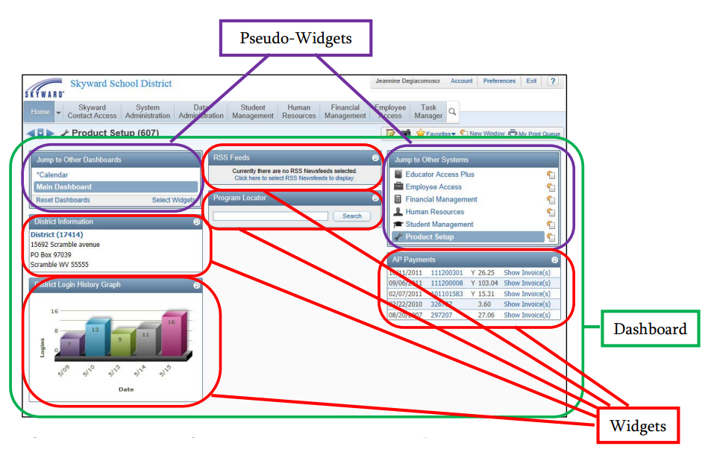Once you sign in to Skyward’s School Management System, the Home screen appears. The Home screen appears in all product lines (Educator Access Plus, Employee Access, Financial Management, Human Resources, Product Setup, and Student Management).

The main area of the Home screen is called the dashboard. The information on a dash-board is contained in pseudo-widgets and widgets. You can create several dashboards and personalize them. Your Home screen can contain six dash-boards (in addition to the Calendars dashboard.) You   
may want to add separate dashboards that contain widgets for each product line.

**Managing Pseudo-Widgets**

Pseudo-widgets allow you to jump to other locations in the software. There are two pseudo-widgets: the Jump to Other Systems pseudo-widget and the Jump to Other Dashboards pseudo-widget. Pseudo-widgets appear on all dashboards (except the Calendar dashboard) and you can’t configure them, move them, or remove them from your dashboard. Pseudo-widgets have a double-line border, and do not have title bar buttons.

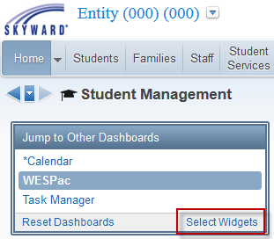**Managing Widgets**

The information on a dashboard is contained in widgets. A widget provides information about your school, district, or an area of Skyward’s School Management System. The dashboard is divided into three columns. Each widget is placed in one of the three columns. However, you can move all widgets to a new location on the same dashboard.

* **To manage your dashboards and widgets, click the Select Widgets hyperlink in the lower-right corner of the Jump to Other Dashboards pseudo-widget**

The title bar of the widget contains the name of the widget on the left. If the widget title becomes underlined when you pause your mouse pointer over it, you can click the name to go to that area or module.

The title bar contains a Refresh button on the right (unless the widget is minimized, in which case the Maximize button appears on the right side of the title bar). When you pause your mouse pointer over the Refresh button, up to four additional buttons appear that allow you to configure the widget.

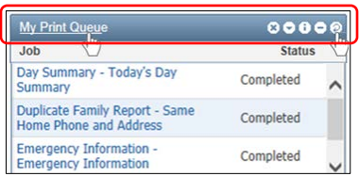

**SETTING YOUR PREFERENCES**

You can set several Preferences that are specific to you. Preferences control things such as how information looks in Skyward’s School Management System, what your shortcut keys are, and the format used when you export reports. Setting Preferences affects only your user account and are managed via the Preferences link in the upper-right corner   
of the screen.

**THEME COLOR – Formats the color of your screens in the software**

**REPORTS – Determines how reports are managed**

* **Display Open/Save Dialog Before Displaying Reports:** Allows reports to display properly on Mac computers running Firefox
* **Automatically Open PDF Reports Upon Completion:** Allows a completed PDF report to automatically open
* **Spreadsheet Format:** Format to be used when exporting Browse screen information to a spreadsheet

**INTERFACE – Determines how screens and windows are managed**

* **Dim Background When Displaying Alerts:** Dims items in the background when an alert window appears on the screen
* **Maximize Large Windows:** Maximizes larger screens when you open them in your browser
* **Disable Interface Animations:** Turns off all interface animations such as menus fading in or out. *TIP: Selecting this option may improve performance on computers with limited resources*
* **Look Up Accounts by Account Dimension:** Automatically opens the Detail Account Selection screen in Finance Management

**BROWSES – Determines how Browse screens are managed**

* **Automatically Display Popup Browse Details on Mouseover:**  Causes a records browse details to automatically appear when you pause your mouse pointer over one of the records headings.
* **Display Browse Row Numbers:** Causes a number to appear next to each record to indicate its placement in the list. In a list with 20 records, the top record would be number 1 and the bottom record would be number 20, regardless of how you sort the list

**NAVIGATION – Allows you to configure navigation options**

* **Use System Name for Home Menu:** Causes the name of the current product line to appear in place of the word “Home”   
  on the Home Screen.
* **Display Data Mining Favorites in General Favorites Menu:** Displays Data Mining reports that are marked as Favorites
* **Enable Favorites Heads Up Display / Favorites Shortcut Key:** Displays your Favorites menu as soon as you hold down the shortcut key for Favorites (as designated in the Favorites Shortcut Key box).

**ACCESSIBILITY – Determines how data in the software appears**

* **Show Icon Text:** Shows text next to unnamed buttons that explains what they do
* **Use Larger Font Sizes:** When enabled, the font sizes throughout the product increase to a larger size
* **Use High Contrast Color Theme:** Maximizes the contrast between the background and foreground colors

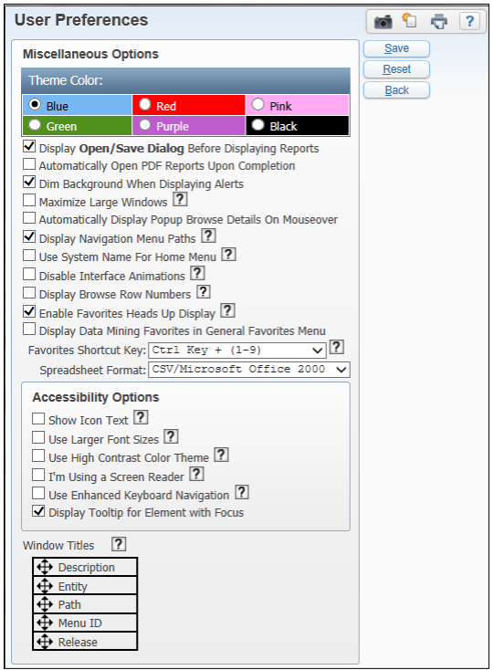

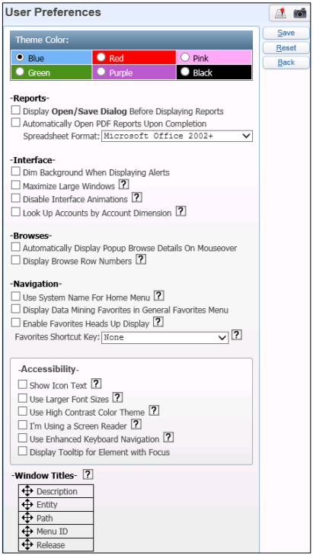

* **I’m Using a Screen Reader:** Shortens the titles on browser windows to a description of the page to make these items easier to read for visually impaired users. A message also informs you when a pop-up is about to appear. *TIP: Don’t enable this option unless you are visually impaired and   
  are using screen reader software*
* **Use Enhanced Keyboard Navigation:** Allows you to more easily navigate through a menu using the Tab key on your keyboard. This option also overrides the program’s default cursor placement and instead causes the cursor to move across the page in a linear manner as you tab through the fields.
* **Display Tooltip for Element with Focus:** Displays a short description of a button, field or hyperlink when you pause your mouse pointer over it.

The Window Titles option customizes the title display of the screen. This option determines the order in which information appears in your browser’s title bar.

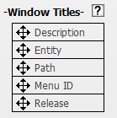 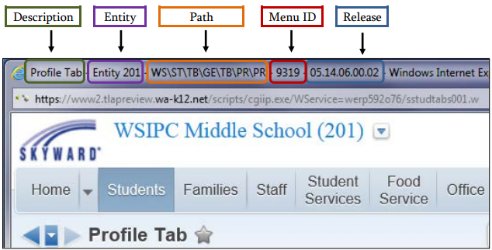

**PROGRAM LOCATOR**

You can use the Program Locator to quickly locate an area within a module, or to locate an area anywhere within the product line you are currently in.

To use the Program Locator:

* + - To find an area within the product line you are currently in, click the Search button to the right   
      to the module tabs

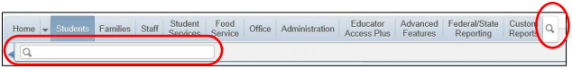

* + - To find an area within a module, click a module name such as Students

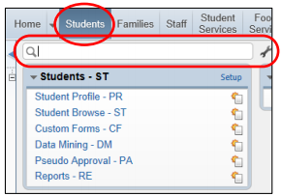

* + Click inside the Program Locator box and type the name of the area. As you type, all matching areas   
    (which you have the security level to access) appear.
  + Click an area to navigate to that area.

**ACCESSING RECENTLY USED MODULES**

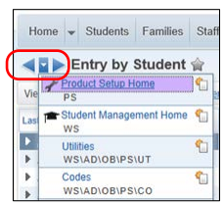There are three ways to access recently used modules. Each way allows you   
to access other modules more quickly than using the navigation path.

* + From any screen, click the Forward or Back Arrow under the Home tab   
    to move forward or backward through your recently accessed modules
  + From any screen, click the Center arrow button under the Home tab to display the list of recently accessed modules and click a module name.
  + From the Home screen, click a module name in the Recent Programs widget (if you have the Recent Programs widget selected to show on your Home screen dashboard.)

**BROWSE SCREENS**

Browse screens are common in Financial Management, Human Resources, and Student Management. On browse screens you can to view many records at once and select a record to modify.

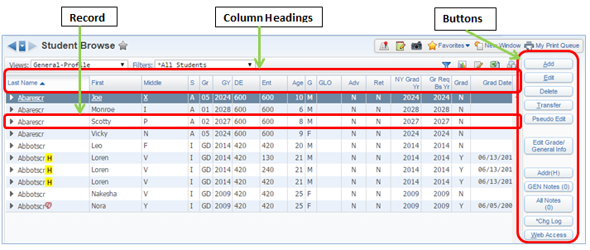

Every browse screen contains View and Filter features. Filters let you choose which records appear on the browse screen for viewing and editing. Views change the type of information you see in the columns.

You can easily change how many records appear on a browse screen. The browse screen can show between 10 and 2000 records. If you choose to display many records, the screen may load more slowly.



Three tools that help you locate a record appear at the bottom of every browse screen.



1. Navigation arrows help you move through records quickly 
2. You can use the Lookup box to quickly locate a record. 
3. You can use the Lookup by Letter function to jump to the set of records that begin with that number or letter.

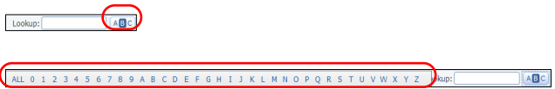

You can display the summary information in a browse screen in three different formats: a chart, a spreadsheet, and a printer-friendly version. This section shows you how to use each format.

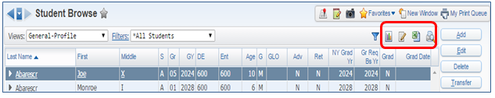

 The Chart Options button displays browse screen data in the form of a chart. You can choose from chart options such as a pie chart or a bar chart.

 The Processing List Option allows you to create a processing list from the data displayed on a browse screen honoring any filter that has been applied.

 The Export Options button exports the data from records in the current browse screen to a spreadsheet.

 The Create printer friendly display of this browse button displays the records on the current browse screen in a printer-friendly format.

You can use any column heading on your browse screen to sort records by clicking the heading of the column you want to sort the records by. The records automatically sort according to the heading you selected. You can sort records in descending or ascending order.

Most records have more information than you see when the browse screen opens. Once you locate a record, you must select it before you can modify or view details for that record. A dark blue background appears behind the selected record. Once you select a record, expand the record to show the headings related to that record by clicking the arrow  to the left of the record. A list of headings appears.

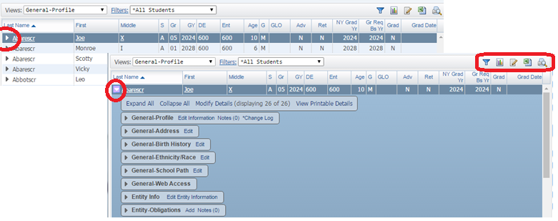

Once you expand the record and see all the headings, you can expand each heading and view details about the record.

These details are called browse details. To access browse details, click the arrow next to the record.

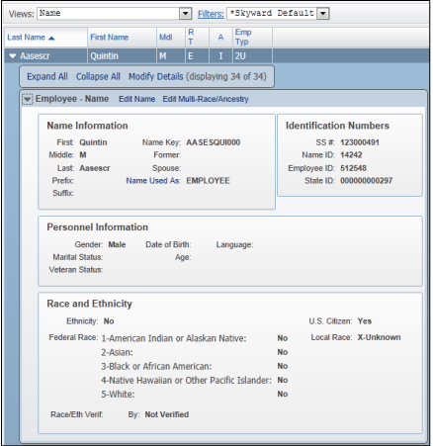

When you expand a record, four hyperlinks appear above the headings. Each hyperlink lets you define how the browse details of the records look on the screen.

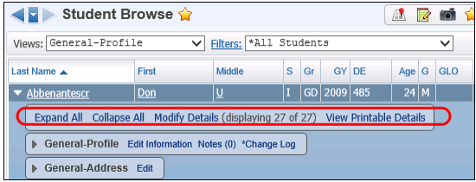

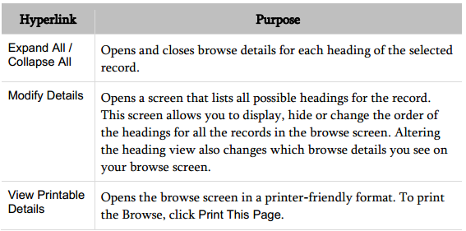

**BROWSE VIEWS AND FILTERS**

Selecting a Browse View allows you to control the information and options that are available for selection when you configure a filter. In addition, a Browse View controls what type of data you see in the browse.

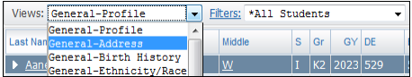

Once you select a Browse View, you can configure a filter to specify which records appear on the browse screen. There are two types of filters: predefined filters and custom filters. Every browse screen offers predefined filters. A predefined filter has an asterisk in its title.

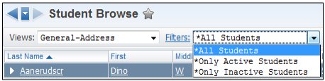

You can use any of the predefined filters to create a custom filter or you can create one from scratch. Filters you create are linked to the Browse View you select when you create the filter. This new filter appears only in the list of filters for that Browse View.

You can also create a Quick Filter to select records that appear on the browse screen. You can’t save Quick Filters, but if you apply a quick filter to a browse screen, it remains in effect on that screen until you remove or reset it. Quick Filters let you filter the Browse data by any column on the browse screen.

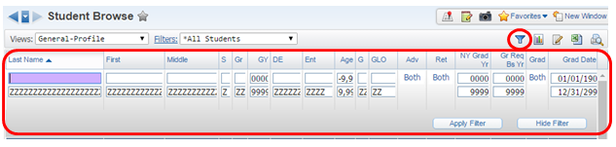

The filter that is active for the Browse screen always defines the records that appear on that Browse screen. If you can’t find a record in the Browse screen, verify that the record you’re looking for is within the filter’s parameters.

When you add a quick filter to a browse screen, the Quick Filter remains in effect on that screen, even if you leave the screen or sign out.

**Managing Slow Loading Browse Filters**

Sometimes, browse filters and customized browse settings can cause your browser to load slowly. For example, a browse filter may take a long time to load if you have selected more than 500 records to display. These can be managed through the Account hyperlink in the upper-right corner of the screen.

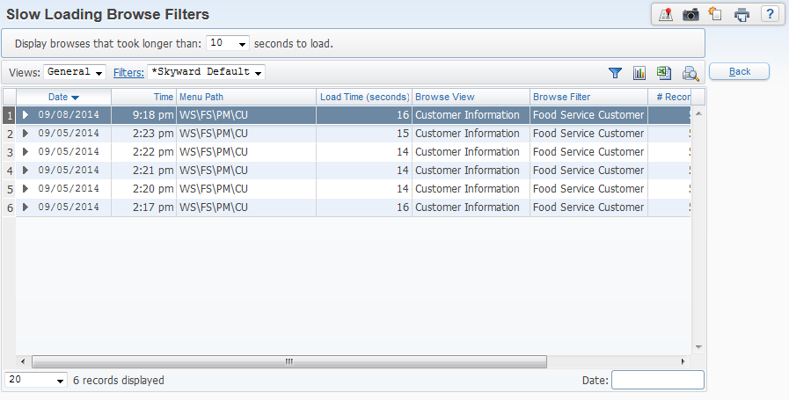

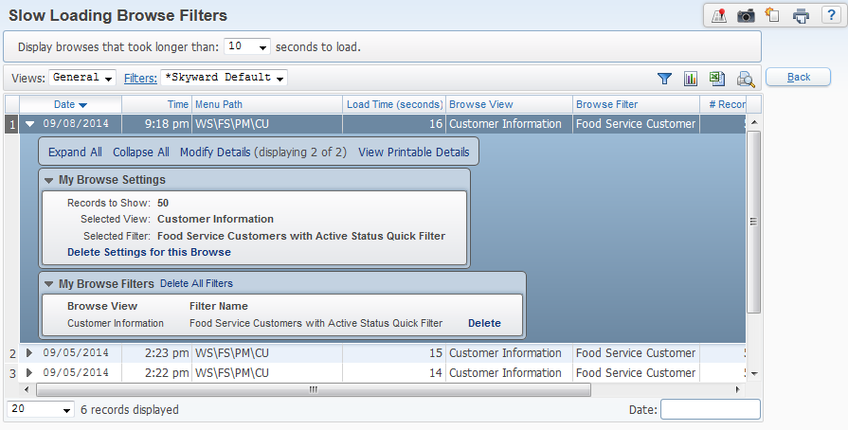

The load time column shows you how many seconds each filter takes to load.

Expand one of the filters.

You can expand the My Browse Settings area and Delete Settings for this Browse

You can expand the My Browse Filters area and Delete All Filters to remove all filters from the browse screen.

You can expand the My Browse Filters area and Delete from a single filter listed.

**POP-UP BROWSE DETAILS**

If enabled in your preferences, the Automatically Display Popup Browse Details on Mouseover option causes a record’s browse details to automatically appear when you pause your mouse pointer over one of the record’s headings.

A browse detail pop-up lets you quickly see the browse details while you’re on the browse screen without having to expand the record’s heading. If you select this option, when you pause your mouse pointer over the heading of a browse record the details appear in a pop-up box

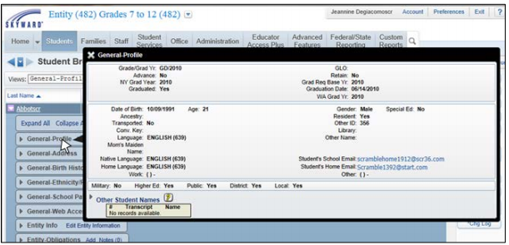

**THE TOOLBAR MENU**

The toolbar menu appears at the top of many screens in Skyward’s School Management System.

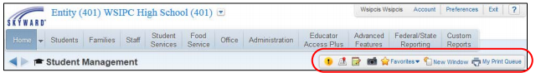

 **Alert**

The Alert button may appear at the top of your Home screen as a button on your toolbar. The Alert button appears if something needs your approval such as online registration verifications or employee time-off requests. This button is available only for users who have permission to authorize the entry of this kind of information.

 **Student Locator**

The Student Locator button on the toolbar is available only to Student Management users. When you click Student Locator, enter the student’s name into the Student box to locate any student. Once you enter the student’s name into the Student Locator, a screen appears containing that student’s demographic and scheduling information. This allows you to determine a student’s location (according to their schedule) without navigating away from the area you’re in

 **Notes**

You can use the Notes button to add a note that is specific to the area of Skyward’s School Management System you’re in when you add the note. Because these notes can be shared with all users in the district, notes can help provide procedural information to people who access a specific area.   
  
If the Notes button is followed by a number in parentheses, that number of notes already exist for that area.

 **Capture Screen**

You can use the Capture Screen button to take a screenshot of the information on your screen. This screenshot is sent to the Print Queue and is saved as a PDF.

 **Favorites**  
The Favorites option lets you bookmark areas of Skyward’s School Management System so that you can get to another area with a single click. When you use a Favorites bookmark to go to an area of the product, the screen displays the view and filter that you used the last time you visited that screen. It does not display the view and filter that you used when you saved the screen as a Favorite in the first place.

You can use the Favorites button to quickly add an item to your Favorites. When you use the Favorites button, you choose the name for the Favorite.

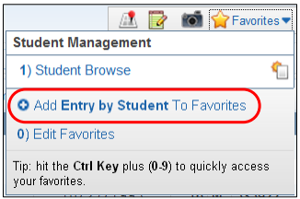

You can use the Star button to quickly add an item to your Favorites. When you use the Star button, you are not prompted to type a name for the Favorite. The name is created automatically.

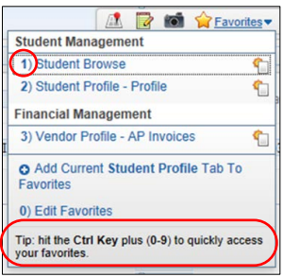

 

If enabled in your preferences, when you select the Enable Favorites Heads Up Display option, you can choose a shortcut key to use in conjunction with the Favorites menu. This allows you to press the shortcut key and a number between zero and nine to quickly access your Favorites.

 **Create New Window**

The New Window button opens a duplicate screen of the screen you’re viewing. You can then navigate to a different area of Skyward’s School Management System using the new screen. This allows you to work in two different areas simultaneously.

 **My Print Queue**

The My Print Queue screen shows reports you’ve recently run and the status of each report. When you run a report, it has a Queued status, then it changes to a Running status, and when it is done it changes to a Completed status. If a report fails before it’s done, an Error status appears.

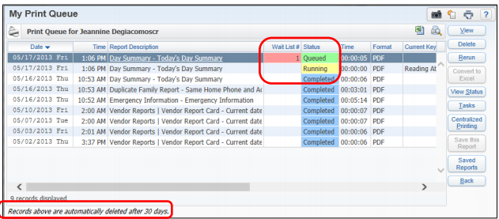

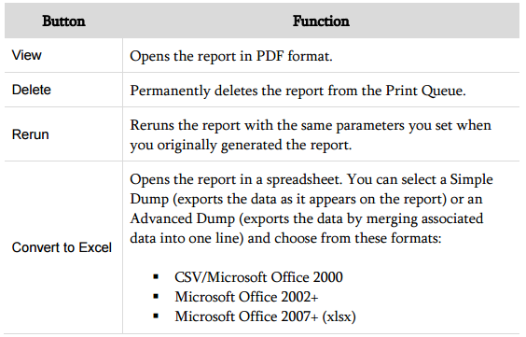

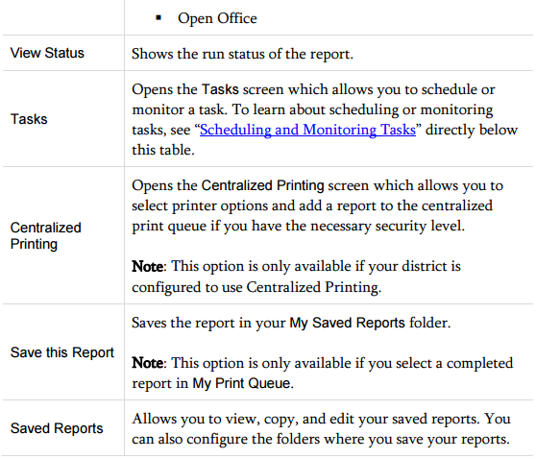



**Scheduling and Monitoring Tasks**

When you click the Tasks button on the My Print Queue screen, the Tasks screen opens. From the Tasks screen, you can schedule and monitor tasks. You must have the appropriate security level to schedule tasks. Consult with your district’s system administrator if you need to access Tasks.

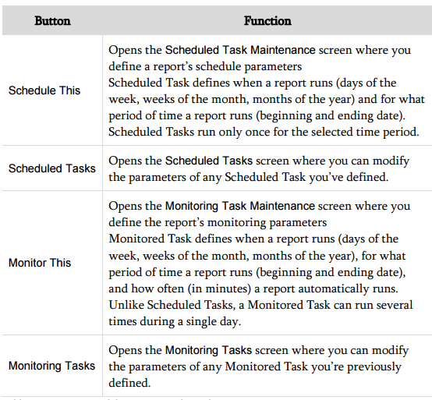

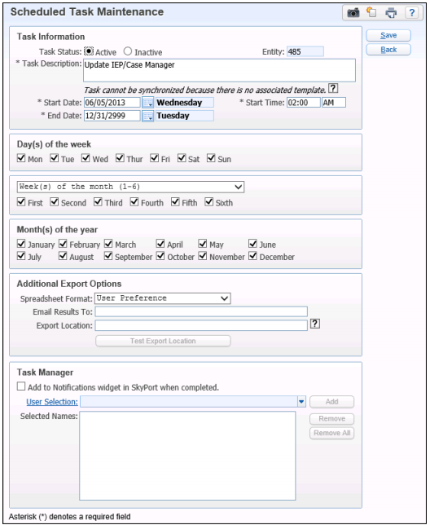 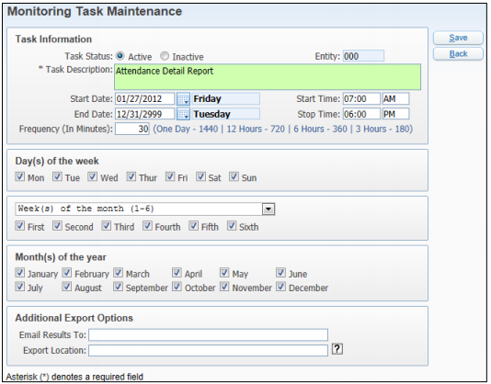

**Recommendations and Restrictions on Scheduling**

Districts should understand the following recommendation and restrictions when setting up a Scheduled Task.

**Scheduling a Report to Run Daily or Several Times a Day**

In the Day(s) of the week, Week(s) of the month(1-6), and Month(s) of the year areas, select all the check boxes to have the print job run daily. If you want a report to run several times in a day, create several scheduled tasks with different start times.

**Restrictions for Scheduled Tasks**

Schedule tasks to run between 7:00 AM and 10:30 PM to avoid conflicts with nightly server maintenance.

**MENU PATHS**

To perform a task in Skyward’s School Management System, you follow a path to get from a general area to a specific area. The following is an example of a menu path provided in a procedure.

**Attendance Period Detail Report: Student Management\Office\AT\RE\AR\DR\PD**

**- or - WS\OF\AT\RE\AR\DR\PD**

Every path begins with the product line name: Human Resources (WH), Student Management (WS), Financial Management (WF), Product Setup (PS) or Educator Access Plus (WA).

**Student Management**\Office\AT\RE\AR\DR\PD - or - **WS**\OF\AT\RE\AR\DR\PD

The next element of the path is the button at the top of the screen. This part of the path may be the tabs full name or the two-letter abbreviation. For our example, we want the Office button.

Student Management\**Office**\AT\RE\AR\DR\PD - or - WS\**OF**\AT\RE\AR\DR\PD

The two-letter abbreviations for each button in Student Management are shown below:



**ST FA SF SS FS OF AD EA AF SR CR**

The next element of the path is a two-letter abbreviation that specifies the module. In this case, it’s Attendance.

Student Management\Office\**AT**\RE\AR\DR\PD - or - WS\OF\**AT**\RE\AR\DR\PD

The remaining elements of the path are other abbreviations that specify the module area. Our path is leading us   
to Reports, then to Attendance Reports, then Daily Reports and finally Period Detail

Student Management\Office\AT\**RE\AR\DR\PD** - or - WS\OF\AT\**RE\AR\DR\PD**

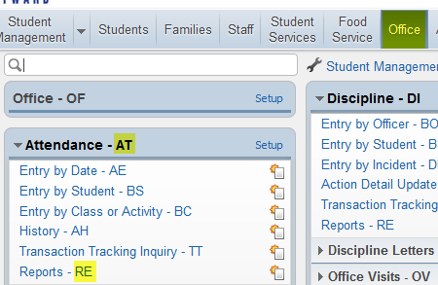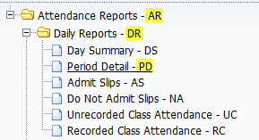

**Navigating to Setup Options**

Setup links allow you to access Codes, Configuration options, and Utilities for modules or areas. When you click the Setup link, the Codes (CO), Configuration (CF), and Utilities (UT) options appear. The following is an example of a menu path that contains a setup element.

**Attendance Mass Add for a Single Day: Student Management\Office\AT Setup\UT\MA**

**- or - WS\OF\AT\PS\UT\MA**

In the second path, the two letter abbreviation **PS** stands for Product Setup.

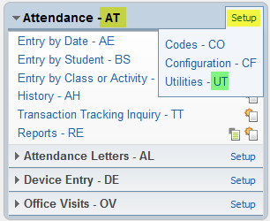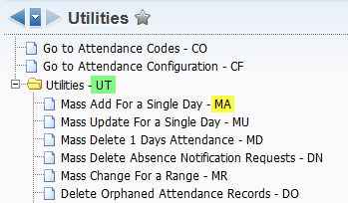

**HELP MENU**

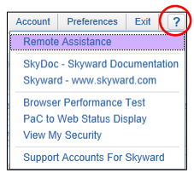You can quickly access the Help menu from any screen in Skyward’s School Management System by clicking the Help button in the upper-right corner of the screen.

**SkyDoc – Skyward Documentation:** Allows you to access the SkyDoc library, which contains information about various processes, reports and utilities. Many SkyDoc library entries offer tutorials that explain a feature’s purpose and how to use it.   
You can also view WSIPC’s Guides from SkyDoc:

* Click the plus sign next to WSIPC in the menu on the left side of the screen,
* Click 00 – WSIPC Educational Materials.
* Select the product line, then continue to the module, area or process.

SkyDoc also contains Student State Report examples, descriptions and specifications that you may find helpful. To view this information in SkyDoc:

* Click the plus sign next to WSIPC in the menu on the left side of the screen
* Click WS – Web Student Management > Federal/State Reporting > Washington State Reports > Reports
* Select the appropriate report category.

**Browser Performance Test:** Runs diagnostic testing on your browser that may help troubleshoot performance issues with the Skyward School Management System.

**View My Security:** Displays a list of menu items that you have security to access, and your security level for each item.

**QUICK PRINT FAVORITES**

Quick Print reports may now be saved as favorites to allow for quicker access.

After you click Quick Pick, select the report and template options, click **Make Favorite.**

Give the template a name and click **Save**.

This will add the selected report template as its own button on the profile tab, as shown below:

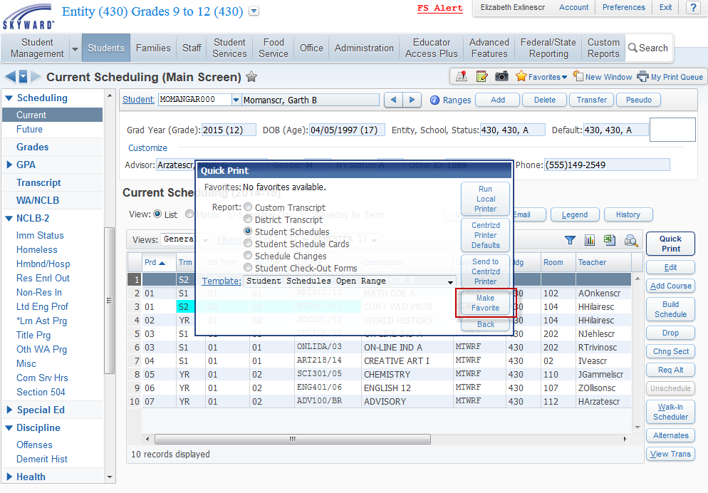

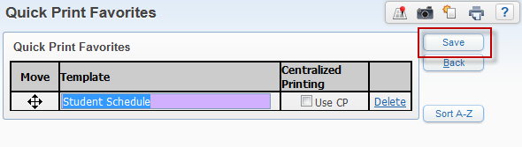

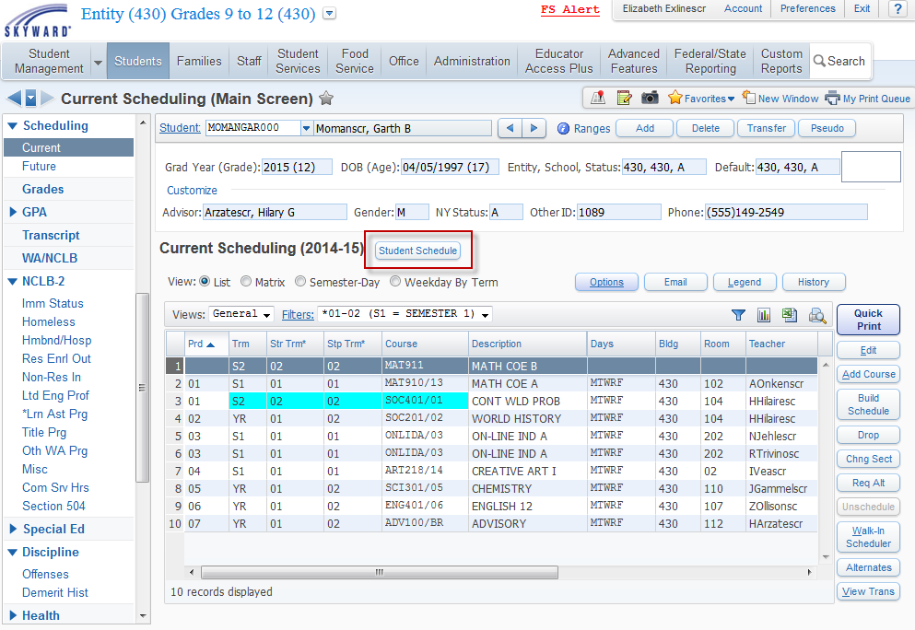

**KEYBOARD SHORTCUTS (may be browser dependent)**

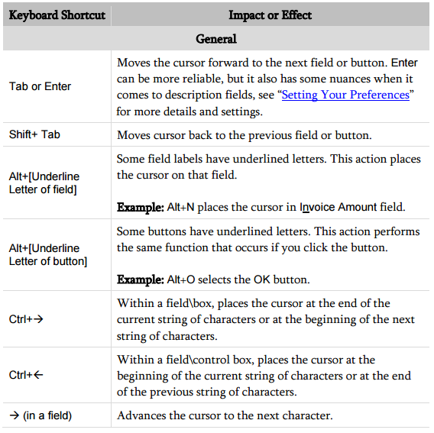

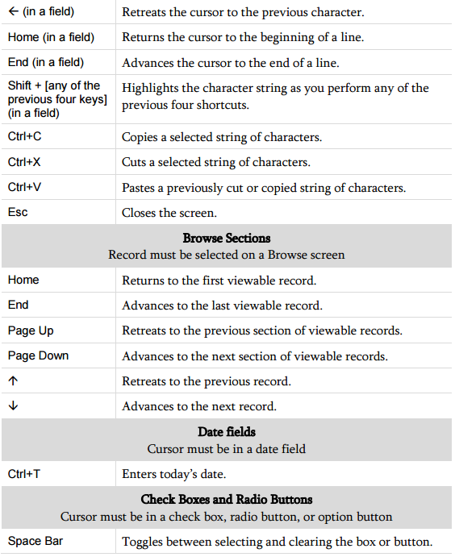

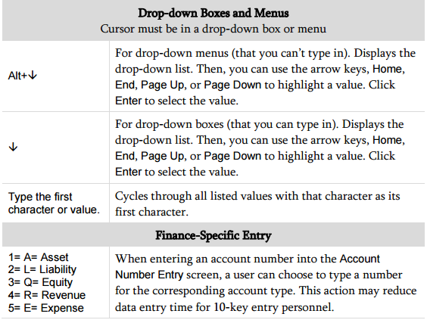



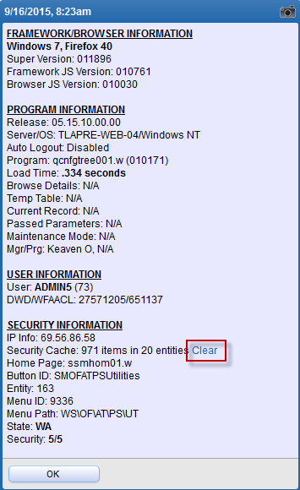

**CLEARING THE SECURITY CACHE**

Sometimes it’s necessary to clear the cache in Skyward because of speed issues or  
items that are not displaying correctly (such as updated student photos that aren’t  
refreshing). To do this, press the **F12** key on the keyboard.

A pop-up window will display, showing such information as browser and operating   
system version; program details and load time; current menu ID, menu path, and   
security level.

To clear the security cache, click the **Clear** hyperlink under Security Information.  
You will be prompted “Are you sure you wish to clear your security cache,” click  
Yes. Once you have cleared the cache in Skyward, press F5 on the keyboard to   
refresh your browser session.