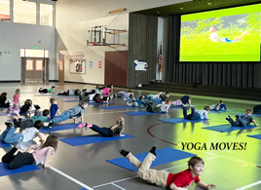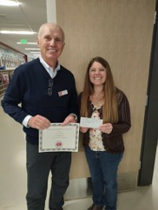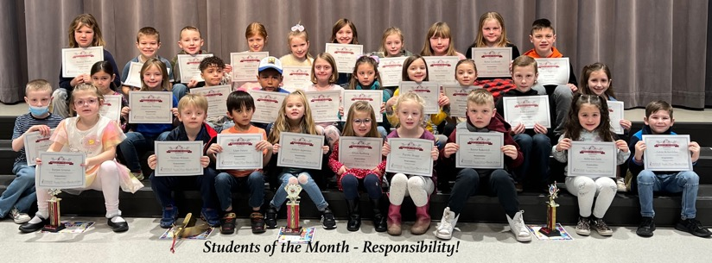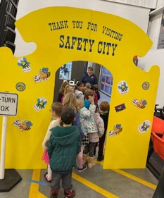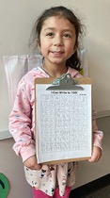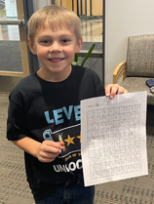

Parents, as we move into spring, student activities and events pick up the pace. If you anticipate wanting to **volunteer** and haven’t yet been cleared, please fill out a **volunteer application** now so that you are set to go. You may pick up a form from our office or find it online at:

<https://chehalisschools.org/forms/>

The Chehalis School District’s Highly Capable program will be accepting

nominations this month. Nomination forms will be available in the office by Friday, March 3rd. The window for accepting forms will close on March 24th at 4:00 pm. If you feel your child is performing at a significantly advanced academic level, you are welcome to fill out a form.

Non-Discrimination/Equal Opportunity Statement Chehalis School District does not discriminate in any programs or activities on the basis of sex, race, creed, religion, color, national origin, age, veteran or military status, sexual orientation, gender expression or identity, disability, or the use of a trained dog guide or service animal and provides equal access to the Boy Scouts and other designated youth groups. The following employees have been designated to handle questions and complaints of alleged discrimination:

El Distrito Escolar de Chehalis no discrimina en ningún programa o actividad por sexo, raza, credo, religión, color, origen nacional, edad, estado veterano o militar, orientación sexual, expresión o identidad de género, discapacidad o el uso de un Guía de perros entrenados o un animal de servicio y proporciona igual acceso a los Boy Scouts y otros grupos juveniles designados. Los siguientes empleados han sido designados para manejar las preguntas y quejas de supuestas discriminaciones:

Title IX/Affirmative Action Officer  Section 504/ADA Officer

Jeff Johnson, 310 SW 16th Street Chehalis, WA 98532  Katie Howell, 310 SW 16th Street Chehalis, WA 98532

(360) 807 7235 [jjohnson2@chehalisschools.org](mailto:jjohnson2@chehalisschools.org) (360) 807-7245 [khowell@chehalisschools.org[](mailto:khowell@chehalisschools.org[)

Civil Rights Compliance Coordinator

Debby Gregory, 310 SW 16th Street Chehalis, WA 98532

(360) 807-7235 dgregory@chehalisschools.org

 Chehalis School District Community Newsletter  “The Learning Network,” can be accessed online through the district’s website at [http://www.chehalisschools.org](http://www.chehalisschools.org/).

Chehalis School District Annual School’s Report  Chehalis School District and the State of Washington believe that important information about local public schools should be provided to educators, parents, community members and the general public. The combined support of these various stakeholders ensures the success of all students. Information regarding current and past test scores, demographics, teacher qualifications, graduation and dropout rates for secondary students, and the status of school improvement can be obtained from the following website: <https://washingtonstatereportcard.ospi.k12.wa.us/> Search for Chehalis School District and click on the school of choice.

Printed copies of the annual school’s report or newsletter may be obtained from the Chehalis School District Office at 310 SW 16th Street, Chehalis, WA 98532 (360) 807-7200. You may also log on to the district website at [http://www.chehalisschools.org](http://www.chehalisschools.org/) and click on the appropriate link to view each document.

Title I Notification

Parents can request the following information regarding instructional staff who work with their children:

• Whether or not the child’s teacher has met state certification for the grades and subjects she/he is teaching.

• Whether or not the teacher is working with an emergency or conditional certificate where state certification criteria has been waived.

• The baccalaureate degree major of the teacher and any other graduate certification or degree held, including field of discipline of the certificate or degree. • If the child receives instructional services from a paraeducator, the paraeducator’s qualifications.

The Lewis County Retired Teacher’s Assoc. recently made a generous donation to Joy Rake’s room for the purchase of classroom books!

***If your child rides a bus, please read this!!***

The **Traversa Ride 360 mobile app** provides secure access to student routing information, which can include the bus stop, route, driver, and bus number. You can also view the bus route and current location of the bus enroute to your student’s destination. The app is available through the Google Play Store. If you have any questions when setting up an account, call the transportation dept. at 360-330-7628.

*Thanks*

*so much*

*for*

*being here with us!*